Disk Usage

Thursday, May 17 after HANA DB upgrade and execution of

ALTER SYSTEM RECLAIM LOG;

alter system reclaim datavolume 120 defragment;

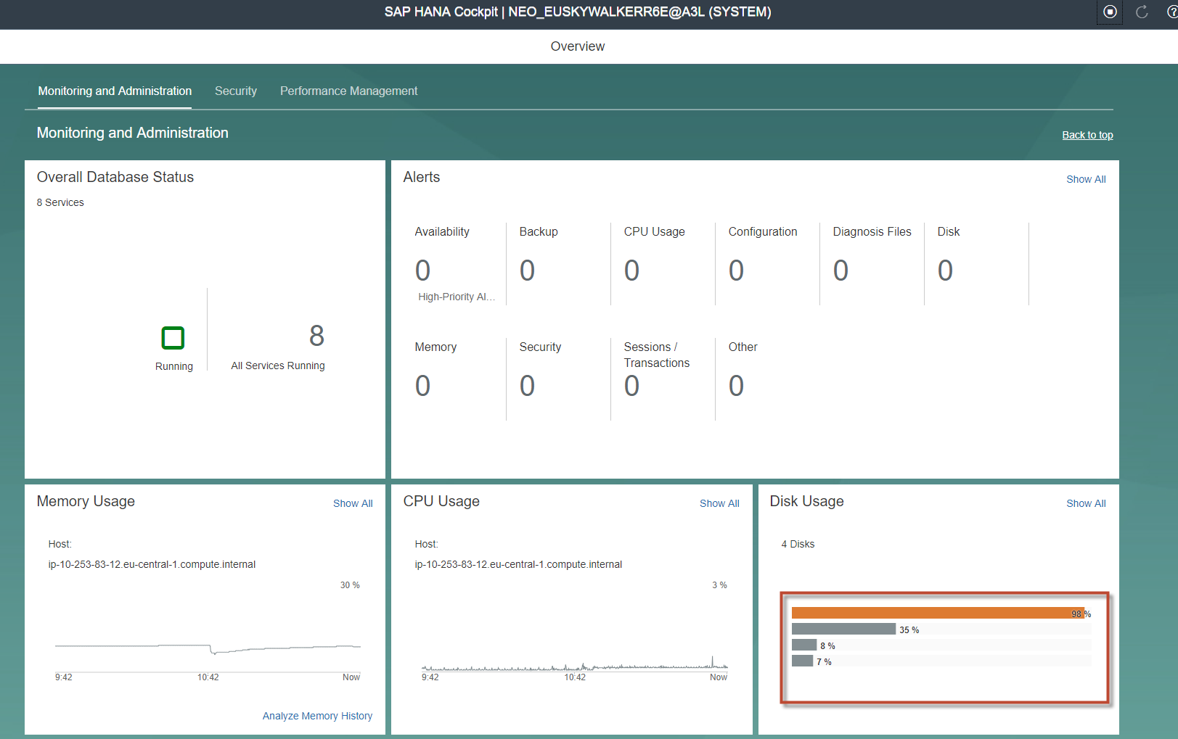

Friday, May 18, no further activities from our side

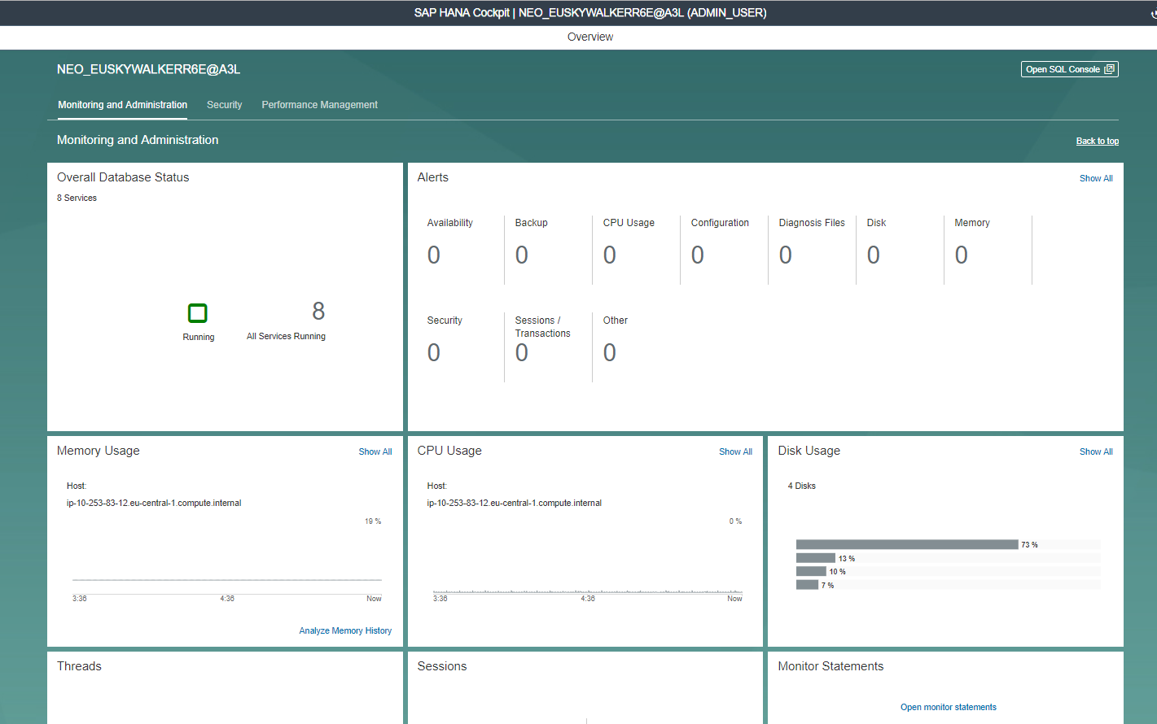

Tuesday, May 22, no further activities from our side

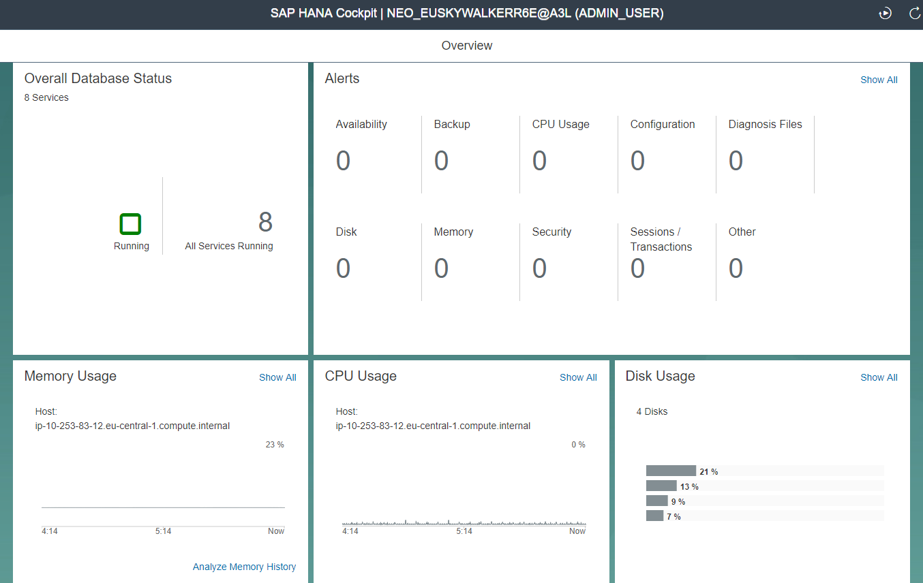

HANA Studio

